We will create a new program to do the Following :-
1- Export all TEXT STRING from SCREEN , REPORTS , MENU AND DIALOGS TO A TABLE
The program will create a unique record for each text with the same width
The table will hold an identifier key and the English string and a reference key to display from witch screen or report.
After getting the translating strings the same program will replace the English text with the translated text.
2- a utility to display English Text in a browse and behind the English string the translator will able to type the translation words but we have to give him the same width of the English Text to type his translating .
Notes :- all language will be in a separate file
The utility will work outside ARIA27.

We need to export the English string text from the Followings file

- Screens
Used the screen file same as open any DBF file ( use ScreenfileName shared )
We have to export the English text from the Flowing Fields :-
Object | ObjType | field name
Text | 5 | Expr
Button | 12 | Picture , Ini_value
Radio Button | 13 | Picture , Ini_value
Check Box | 14 | Picture

- Reports
Used the report file same as open any DBF file ( use ReportfileName shared )
We have to export the English text from the Flowing Fields :-
Object | ObjType | field name
Text | 5 | Expr

- Menu File ( SycMenu.dbf )
field name | Notes
Csub_Part
CSub_mesg
CHlp_Topic

- Message File
field name | Notes
Mdlobj | If the cDlObjTyp = B then we have to export the text without “ \> “

- Sydfields
field name | Notes
CFld_head
CFld_Msg
MvEnTries

- Sydfiles
field name | Notes
MFil_desc

- SydObjct
field name | Notes
CprgLname

- SydAppl
field name | Notes
Cap_name

- SydReport
field name | Notes
Crep_name
MRep_desc

10 – SyrepUvr
field name | Notes
Cfld_head | Only records that have ExpTyp = F OR ( ExpTyp = V AND AskRnTim = .T. )
Mfld_desc | Only records that have ExpTyp = F OR ( ExpTyp = V AND AskRnTim = .T. )

IN All the pervious files the program must seek in the Ouput file to check if the English string is exit with the same lengh . And any records didn’t exported ( was exported before and have been deleted in the Master files ) must be deleted .

Files
- Language File :- Sydlange

field name | Descr | Type | Width
ClangID | A identifier for each language ( Esp = Espanish , ITL = Italy , FSH = Frensh ) | C | 3
Clangdesc | Language Description ( name ) | C | 10
CLangPath | Language directory where the Imported file will be saved  Under v:\aria27 will have a language folder contain folder for each language to save the imported file ( the file that will be received from the Translator ) | C | 60
CDevPath | The development directory ( the directory that will hold a copy from the Aria27 after importing the new language | C | 60

2- the Output file to hold the exported language.
The Output file name is SyEngTxt.DBF
The Structure as Following :-

field name | Descr | Type | Width
CStrngNO | A sequential no to be identifier for each record | C | 6
CStrngEng | The output English text | C | 150
CStrngFnt | The text font | C | 30
CStngSize | The Maximum Text Size | C | 5
CStrngRef | A reference filed to display from witch object | C | 60

- the imported file
the file that we will get it from the translator
the file name will be Sy+ Sydlange.ClangID+’Txt.DBF

field name | Descr | Type | Width
CStrngNO | A sequential no to be identifier for each record | C | 6
CStrngEng | The output English text | C | 150

The Layout

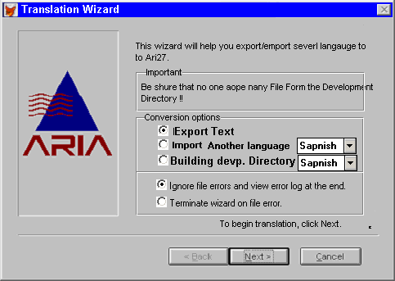

- Export Text . : when we select Export Text the program will export the English text from the files that we have mentioned in page 1 and 2.
Then the program will compress the output file to be sending It to the translator.

- Import language : when we select Import language , we have to select from the popup the language that we need to be imported ( we get this popup from language file ) . the program will copy the imported file in the Imported language path ( from language file ) exp ( v:\Aria27\language\Spanish )

- Building Devp. Directory :- when we select Building development directory , we have to select the language form the popup . then the program will make a copy from the v:\aria27 to the language development directory ( from language file ) and import the text with the specified language .

Recommendation for the maintenance :-

- the split program needs to be change to do the same thing in # 3 . the program has to copy the v:\aria27\ to the language development directory then the results that we will have split directory for each language .
- also the Service Pack . have to generate service pack for each language using the same way in # 3

- the Text Translating Screen

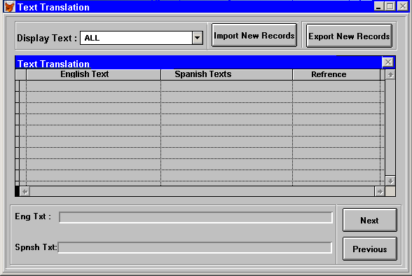

- this program will be available at the translator site .
- From this screen he can import the new records send it from Aria ( the out put file created from option # 1 in the translation wizard )
- From this screen he can export the translator file to be sending by mail .
- Display text popup contain 3 elements .
- ALL ( display in the browse all text ( translated text and not translated text )
- Not Translated Text ( display in the browse Not translated text only )
- Translated Text ( display in the browse translated text only )

